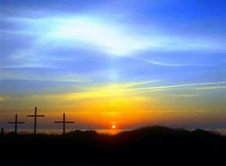
Easter Sunrise Service

and Breakfast
April 1st at 9:00am
Calvary Baptist Church
414 S. Main St. Oberlin
No 10:00am Bible Study and Sunday

